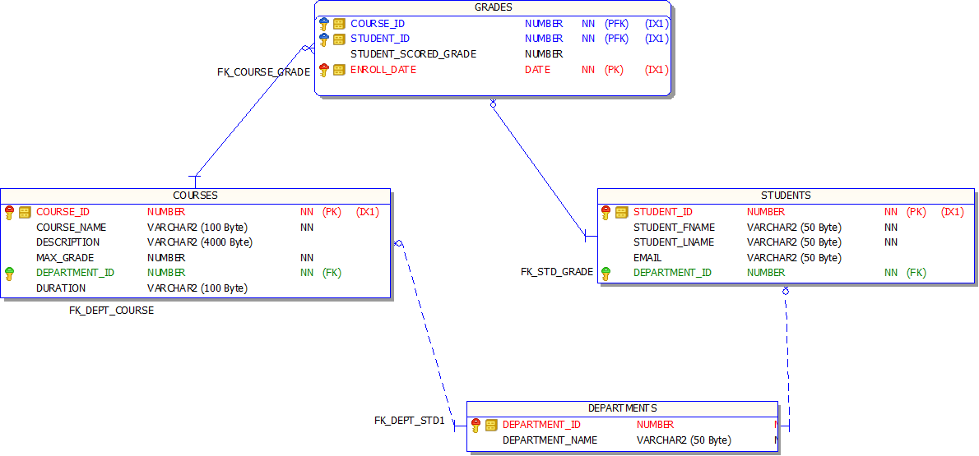

CREATE TABLE COURSES

(

COURSE_ID NUMBER,

COURSE_NAME VARCHAR2(100 BYTE) NOT NULL,

DESCRIPTION VARCHAR2(4000 BYTE),

MAX_GRADE NUMBER NOT NULL,

DEPARTMENT_ID NUMBER NOT NULL,

DURATION VARCHAR2(100 BYTE)

)

LOGGING

NOCOMPRESS

NOCACHE

NOPARALLEL

MONITORING;

CREATE TABLE DEPARTMENTS

(

DEPARTMENT_ID NUMBER,

DEPARTMENT_NAME VARCHAR2(50 BYTE) NOT NULL

)

LOGGING

NOCOMPRESS

NOCACHE

NOPARALLEL

MONITORING;

CREATE TABLE GRADES

(

COURSE_ID NUMBER,

STUDENT_ID NUMBER,

STUDENT_SCORED_GRADE NUMBER,

ENROLL_DATE DATE NOT NULL

)

LOGGING

NOCOMPRESS

NOCACHE

NOPARALLEL

MONITORING;

CREATE TABLE STUDENTS

(

STUDENT_ID NUMBER,

STUDENT_FNAME VARCHAR2(50 BYTE) NOT NULL,

STUDENT_LNAME VARCHAR2(50 BYTE) NOT NULL,

EMAIL VARCHAR2(50 BYTE),

DEPARTMENT_ID NUMBER NOT NULL

)

LOGGING

NOCOMPRESS

NOCACHE

NOPARALLEL

MONITORING;

CREATE UNIQUE INDEX PK_GRADE ON GRADES

(COURSE_ID, STUDENT_ID, ENROLL_DATE)

LOGGING

NOPARALLEL;

CREATE OR REPLACE PROCEDURE UPDATE_STUDENT (

p_student_id IN NUMBER,

p_student_fname IN VARCHAR2,

p_student_lname IN VARCHAR2,

p_email IN VARCHAR2,

p_department_id IN NUMBER

) IS

BEGIN

UPDATE CASE.STUDENTS

SET STUDENT_FNAME = p_student_fname,

STUDENT_LNAME = p_student_lname,

EMAIL = p_email,

DEPARTMENT_ID = p_department_id

WHERE STUDENT_ID = p_student_id;

COMMIT;

EXCEPTION

WHEN OTHERS THEN

DBMS_OUTPUT.PUT_LINE('Error: ' || SQLERRM);

END UPDATE_STUDENT;

SHOW ERRORS;

CREATE OR REPLACE FUNCTION calculate_course_gba(

v_course_id IN NUMBER

) RETURN NUMBER

AS

v_avg_score NUMBER := 0;

v_avg_max_grade NUMBER := 0;

v_course_gba NUMBER;

BEGIN

SELECT

NVL(AVG(g.student_scored_grade), 0),

NVL(AVG(c.max_grade), 0)

INTO v_avg_score, v_avg_max_grade

FROM grades g

JOIN courses c ON g.course_id = c.course_id

WHERE g.course_id = v_course_id;

IF v_avg_max_grade > 0 THEN

v_course_gba := (v_avg_score / v_avg_max_grade) * 4.0;

ELSE

v_course_gba := NULL;

END IF;

DBMS_OUTPUT.PUT_LINE('Course GBA calculated successfully.');

RETURN v_course_gba;

END calculate_course_gba;

/

SHOW ERRORS;

CREATE OR REPLACE FUNCTION caseGBA(

vStudentId IN NUMBER

) RETURN NUMBER

AS

vTotalScore NUMBER := 0;

vTotalMaxGrade NUMBER := 0;

vGPA NUMBER;

BEGIN

SELECT

NVL(SUM(g.student_scored_grade), 0),

NVL(SUM(c.max_grade), 0)

INTO vTotalScore, vTotalMaxGrade

FROM grades g

JOIN courses c ON g.course_id = c.course_id

WHERE g.student_id = vStudentId;

vGPA := NVL((vTotalScore / NULLIF(vTotalMaxGrade, 0)) * 4.0, NULL);

DBMS_OUTPUT.PUT_LINE('GPA calculated successfully.');

RETURN vGPA;

END caseGBA;

/

SHOW ERRORS;

CREATE OR REPLACE TRIGGER trg_check_student_scored_grade

BEFORE INSERT OR UPDATE ON grades

FOR EACH ROW

DECLARE

v_max_grade NUMBER;

BEGIN

SELECT max_grade INTO v_max_grade

FROM courses

WHERE course_id = :NEW.course_id;

IF :NEW.student_scored_grade > v_max_grade THEN

RAISE_APPLICATION_ERROR(-20001, 'Student Scored Grade cannot exceed Max Grade for the course.');

END IF;

END;

SHOW ERRORS;

ALTER TABLE COURSES ADD (

PRIMARY KEY

(COURSE_ID));

ALTER TABLE DEPARTMENTS ADD (

PRIMARY KEY

(DEPARTMENT_ID));

ALTER TABLE GRADES ADD (

CONSTRAINT PK_GRADE

PRIMARY KEY

(COURSE_ID, STUDENT_ID, ENROLL_DATE));

ALTER TABLE STUDENTS ADD (

PRIMARY KEY

(STUDENT_ID));

ALTER TABLE COURSES ADD (

CONSTRAINT FK_DEPT_COURSE

FOREIGN KEY (DEPARTMENT_ID)

REFERENCES DEPARTMENTS (DEPARTMENT_ID));

ALTER TABLE GRADES ADD (

CONSTRAINT FK_COURSE_GRADE

FOREIGN KEY (COURSE_ID)

REFERENCES COURSES (COURSE_ID),

CONSTRAINT FK_STD_GRADE

FOREIGN KEY (STUDENT_ID)

REFERENCES STUDENTS (STUDENT_ID));

ALTER TABLE STUDENTS ADD (

CONSTRAINT FK_DEPT_STD1

FOREIGN KEY (DEPARTMENT_ID)

REFERENCES DEPARTMENTS (DEPARTMENT_ID));